Practical activity: Metal Displacement Reactions
Practical Guide – Metal Displacement Reactions

Aim: To observe the reactions between various metals and metal salt solutions
Notes and guidance
Discuss this practical with your technician colleagues as far in advance as possible, especially if it will necessitate them making up the sets of microscale equipment from scratch. A resource-efficient method of setting up this practical is to provide pre-filled plastic pipettes, but depending on what equipment is available, another microscale system may work better for your school.

Accompanying this practical guide is a worksheet that includes the full method as well as a table. This should be laminated and given to each student/group of students. Solutions should be added to each cell of the table drop-wise as indicated in the method. These sheets can then be easily cleaned up for re-use. If a laminator is not available, a clear OHP sheet can be placed over the worksheet or the paper sheet can be placed in a clear wallet.

Solids can be provided in small bottles with forceps for easy handling. Liquid solutions should be approximately 0.2 M.

A magnifying glass can be provided to help students more easily observe the reactions that take place.

Risk Assessment Notes
A risk assessment must be completed for this practical. The risk assessment should be specific to the class involved and written only by the teaching member of staff. For more guidance refer to CLEAPSS. It is good practice for students to wear safety spectacles during all class practicals and demos.

Magnesium ribbon is highly flammable, ensure none goes missing. Consult CLEAPSS Hazcards for safety and disposal advice: Copper(II) sulfate solution (HC027c), Magnesium ribbon (HC059A), Zinc powder (HC107), Zinc chloride (HC108a), Iron(III) nitrate (HC055C), Magnesium nitrate (HC059b), Iron filings (HC055A), Copper turnings (HC026).

Equipment Per Group | Table (to be laminated – see accompanying worksheet):  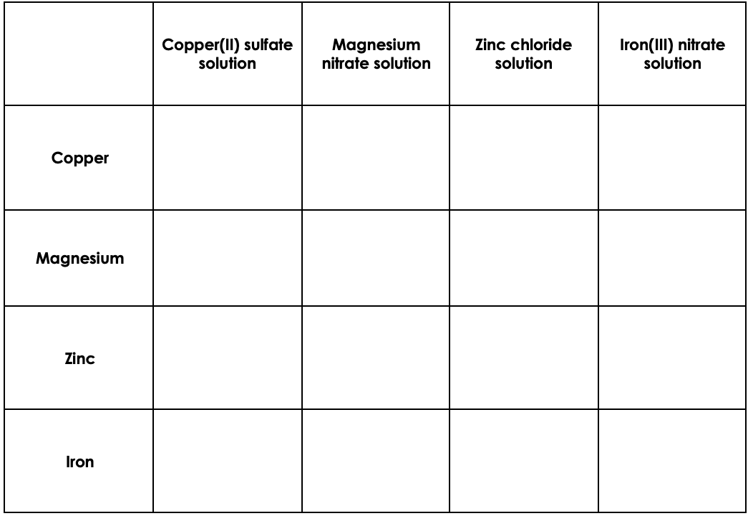
Apparatus:
- Laminated worksheet
- Forceps
- Magnifying glass

Liquid solutions provided in mini plastic pipettes:
- Copper(II) sulfate solution
- Iron(III) nitrate solution
- Magnesium nitrate solution
- Zinc chloride solution

Metal solids:
- Magnesium ribbon
- Zinc metal granules
- Iron granules or filings
- Copper turnings

Method |  | Questions To Ask Students During The Practical
- Add a piece of each specified metal to each cell of the table.  - Add a drop of copper(II) sulfate solution to each metal in the first column and observe and record what you observe.  - Add a drop of magnesium nitrate solution to each metal in the second column and observe and record what you observe.  - Add a drop of zinc chloride solution to each metal in the third column and observe and record what you observe.  - Add a drop of iron(III) nitrate solution to each metal in the fourth column and observe and record what you observe. |  | - What happens to the zinc granules and magnesium ribbon when they contact copper sulfate solution? (They darken in colour.)  - Why is this? (They are covered in a layer of copper.)  - Does iron react upon contact with copper sulfate solution? (Yes, but less obviously so.)  - Why is this? (Iron is less reactive than magnesium and zinc.)  - Which metals react upon contact with magnesium sulfate solution? (None of the metals.)  - Why is this? (Magnesium is the most reactive of these metal elements.)  - What reaction occurs between a given metal and salt solutions of the same metal? (No reaction.)  - Based on your observations of this experiment, list the metals in order of reactivity. (Copper, iron, zinc, magnesium.)
Alternative Methods/Computer Simulations |  | Clearing up
You may wish to do one large-scale version of this experiment as a demonstration. To save resources, you could use this microscale method with a visualiser.  Depending on what chemicals are available, you may wish to add more elements or substitute some of those suggested. Discuss this with your technician colleagues well in advance of the practical as new laminated sheets will have to be prepared. |  | It is important that equipment is returned to the prep room in good order. If safe to do so, rinse used equipment and put it in the used equipment tray. If the trays arrived on a trolley, students must return all trays and equipment to that trolley. Anything dirty needs to be placed into a separate container for washing up. Never put dirty equipment back into a tray with clean equipment.  Consult CLEAPSS Hazcards for waste disposal guidance. As a general rule, metal solids should never be emptied into a sink. Your technician colleagues will be able to offer guidance as to how they would like the class to leave the equipment after the experiment.
Technician Notes
Ensure the solutions you provide are free from contamination and the equipment is as clean as possible.

Discuss this practical with the class teacher ahead of time. Ensure they have considered the risks of this practical and are confident with the techniques used. If necessary, provide them with the CLEAPSS hazcards (identified in the risk section section above) so they are comfortable with the chemicals to be used and how to use and dispose of them safely.

Solutions can be provided in dropper bottles or in pre-filled plastic pipettes. Ensure these are clearly labelled.

